

**APPLIED PHYSICS LAB**

**Lab Report 1: To Find The Resistance of Galvanometer by Kelvin’s Method**

**Submitted To:**

Sir. Haseen Ullah Jan

**Submitted By:**

Ali Asghar

Section C

Registration No. 21PWCSE2059

Department Of Computer Systems Engineering

Fall 2021

**KELVIN’S METHOD**

**WHAT IS GALVANOMETER ?**

It is an instrument for measuring a small electrical current or a function of the current by deflection of a moving coil.

**WHAT IS KELVIN METHOD ?**

The Kelvin double bridge is the modification of the Wheatstone bridge and provides greatly increased accuracy in measurement of low value resistance.

**WHAT IS WHEATSTONE BRIDGE ?**

The Wheatsone bridge is a device used for the measurement of unknown resistance.

**WORKING PRINCIPLE:**

The principle of wheatstone bridge is used in order to measure the unknown resistance i.e. in this case, of galvanometer while knowing the other three resistances.

I shall use the following equation for calculating any unknown resistance X,

$$X=Rg=\frac{RQ}{P}$$

**FIGURE:**

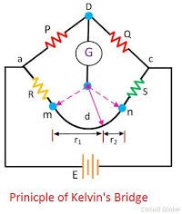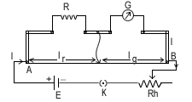

**APPARATUS:**

1. Connecting Wires
2. Galvanometer
3. Battery
4. High Resistance Box (HRB)
5. Post Ofﬁce Box

**PROCEDURE:**

1. Firstly, I applied the resistance in H.R.B. and set the galvanometer within scale.
2. Then I applied the resistance in P and Q by plugging the keys out of the post office box.
3. Then I connected k2 and at a certain resistance, the galvanometer showed no deflection.
4. Then I found Rg by applying the formula.

$$X=Rg=\frac{RQ}{P}$$

**READINGS:**

|  |  |  |  |  |
| --- | --- | --- | --- | --- |
| S No. | P | Q | R | $$X=\frac{RQ}{P}$$ |
| 1 | 100 | 10 | 1000 | 100 |
| 2 | 110 | 100 | 110 | 100 |
| 3 | 100 | 100 | 100 | 100 |
| 4 | 10 | 10 | 100 | 100 |
| 5 | 1000 | 100 | 1100 | 110 |

**AVERAGE READING:**

$$<X> =\frac{100 +100 +100 +100 +110}{5}$$

$$<X> =102 ohm$$

**PRECAUTIONS:**

1. Fix the knobs tightly. Repeat experiment and take mean values.
2. DO NOT ATTACH GALVANOMETER IN PARALLEL WITH ANY E.M.F SOURCE.
3. Make appropriate connections.
4. Clean the wire ends.